

**Tribhuvan University**

**Faculty of Humanities and Social Science A PROJECT REPORT**

**On ANIME STORE**

**Submitted to Department of Computer Application**

**Everest College**

**In partial fulfillment of the requirements for the Bachelors in Computer Application**

**Submitted by**

**Ayush Pakhrin - 6-2-355-2-2020 Robina Shahi - 6-2-355-10-2020 BCA 6th Semester, III Year**

**Under the Supervision of Mr. Santu Deula**



**Tribhuvan University**

**Faculty of Humanities and Social Sciences**

**Everest College**

# Supervisor’s Recommendation

I hereby recommend that this project prepared under my supervision by “**Ayush Pakhrin, 6-2-355-2-2020** and **Robina Shahi, 6-2-355-10-2020**” entitled “**Anime Store**” in partial fulfillment of the requirements for the degree of Bachelor of Computer Application is recommended for the final evaluation.

…………………. **SIGNATURE**

Name: Mr. Santu Deula SUPERVISOR

Lecturer

Faculty of Humanities and Social Sciences Everest College



## Tribhuvan University

**Faculty of Humanities and Social Sciences**

**Everest College**

# LETTER OF APPROVAL

This is to certify that this project is prepared by "**Ayush Pakhrin and Robina Shahi"** entitled “Anime Store” in partial fulfillment of the requirements for the degree of Bachelor in Computer Application has been evaluated. In our opinion it is satisfactory in the scope and quality as a project for the required degree.

|  |  |
| --- | --- |
| **………………………………. Supervisor**  **Mr. Santu Deula**  **Supervisor Kathmandu 44600** | **………………………………. Coordinator**  **Mr. Kamal Pathak**  **Coordinator Kathmandu 44600** |
| **……………………………….** | **……………………………….** |
| **Internal Examiner** | **External Examiner** |
| **Name:** | **Name:** |
| **Date:** | **Date:** |

# ABSTRACT

This report is submitted in the partial fulfillment of the requirement for a Bachelor in Computer Application (BCA), Everest College. The project entitled as ’AR Store’ is an e-commerce website which allows the purchase of anime-related merchandise, manga, stationaries and other collectibles. The system aims to provide an efficient platform for purchasing goods, processing orders, and enhancing the overall shopping experience for customers. It offers them a platform where they can find and purchase their favorite anime merchandise and collectibles. The system aspires to create a thriving online space that not only meets the merchandise needs of anime enthusiasts but also contributes to community-building and engagement within the global anime fandom.

**Keywords:** CSS**,** DFD, HTML, JavaScript, MySQL, PHP

# ACKNOWLEDGEMENT

We sincerely acknowledge and thank those who have contributed their valuable time in helping us to achieve success in our project report on “ANIME STORE”. We would like to express our gratitude to all those who gave us the possibility to complete this project. We want to thank Everest College for allowing us to do this project. We are indebted and thankful to our Project Guide. Mr. Santu Deula to whom we owe their piece of knowledge for his valuable and timely guidance, cooperation, encouragement & time spent doing this project work.

We are immensely obliged to our friends for their elevating inspiration, encouraging guidance, and kind supervision in the completion of our project. We sincerely thank the IT staff for providing us with sufficient information which helped us to complete our project successfully.

**With respect,** Ayush Pakhrin Robina Shahi

**Table of Contents**

SUPERVISOR’S RECOMMENDATION i

LETTER OF APPROVAL ii

ABSTRACT iii

ACKNOWLEDGEMENT iv

LIST OF FIGURES vii

LIST OF TABLES ix

LIST OF ABBREVIATIONS x

CHAPTER 1: INTRODUCTION 1

* 1. Background 1
  2. Problem Statement 1
  3. Objective 2
  4. Scope and Limitations 3
  5. Report Organization 3

CHAPTER 2: BACKGROUND REVIEW AND LITERATURE REVIEW 4

* 1. Background Review 4
  2. Literature Review 4

CHAPTER 3: SYSTEM ANALYSIS AND DESIGN 5

* 1. System Analysis 5
     1. Requirement Analysis 7
     2. Feasibility Analysis 9
        1. Technical Feasibility 8
        2. Operational Feasibility 9
        3. Economic Feasibility 9
        4. Schedule Feasibility 10
     3. Data Modeling (ER-Diagram) 11
     4. Process Modeling (DFD) 13
  2. System Design 14
     1. Architectural Design 14
     2. Database Schema Design 16
     3. Interface Design 17
     4. Physical DFD 21
  3. Algorithm Used 23

CHAPTER 4: IMPLEMENTATION AND TESTING 26

* 1. Implementation 26
     1. Tools Used 26
     2. Implementation Details of Modules 27
  2. Testing 31
     1. Test Cases for Unit Testing 31
     2. Test Cases for System Testing 41

CHAPTER 5: CONCLUSION AND FUTURE RECOMMENDATION 42

* 1. Lesson Learnt 42
  2. Conclusion 42
  3. Future Recommendations 43

APPENDICES 44

REFERENCES 49

# LIST OF FIGURES

Figure 3.1: Agile model of Anime Store Website 6

Figure 3.2: Use-case Diagram 8

Figure 3.3: Gantt-Chart of AR Store 10

Figure 3.4: ER Diagram of Anime Store 12

Figure 3.5: Context – Diagram of Anime Store Website 13

Figure 3.6: Level 1 DFD of Anime Store Website 14

Figure 3.7: System Architecture Design of Anime Store Website 15

Figure 3.8: Database Schema Design of Anime Store 16

Figure 3.9: Login Page Wireframe 17

Figure 3.10: Registration Page Wireframe 18

Figure 3.11: User Homepage Wireframe 18

Figure 3.12: User Product page Wireframe 19

Figure 3.13: Admin Registration page Wireframe 19

Figure 3.14: Admin Login page Wireframe 20

Figure 3.15: Admin Dashboard Wireframe 20

Figure 3.16: Level 0 Physical DFD of Anime Store Website 21

Figure 3.17: Level 1 Physical DFD of Anime Store Website 22

Figure 3.18: Before Rating 24

Figure 3.19: After Rating 24

Figure 3.20: Recommended Product………………………………………………….25

Figure 4.1: Test Evidence 1.1 33

Figure 4.2: Test Evidence 1.2 33

Figure 4.3: Test Evidence 2.1 34

Figure 4.4: Test Evidence 2.2 34

Figure 4.5: Test Evidence 3.1 35

Figure 4.6: Test Evidence 3.2 35

Figure 4.7: Test Evidence 4.1 36

Figure 4.8: Test Evidence 4.2 36

Figure 4.9: Test Evidence 5.1 37

Figure 4.10: Test Evidence 5.2 37

Figure 4.11: Test Evidence 6.1 38

Figure 4.12: Test Evidence 6.2 38

Figure 4.13: Test Evidence 6.3 39

Figure 4.14: Test Evidence 6.4 39

Figure 4.15: Test Evidence 6.5 40

Figure 4.16: Test Evidence 6.6 40

# LIST OF TABLES

Table 3.1: Project Schedule for Anime Store 10

Table 4.2 Test Cases for Unit Testing 31

# LIST OF ABBREVIATIONS

CSS Cascading Style Sheets

DFD Data Flow Diagram

ER Entity Relationship

HTML Hyper Text Markup Language

SQL Structured Query Language

# CHAPTER 1: INTRODUCTION

## Background

The fast development of technology in recent years has drastically changed how we do business and engage with the outside world. The development of e-commerce websites is a crucial result of this digital revolution. These online stores have completely changed how people shop by giving them a simple and easy way to look through, buy, and sell a variety of goods and services. E-commerce, short for electronic commerce, refers to the buying and selling of goods and services over the internet. It has reshaped the retail landscape, providing both businesses and consumers with unprecedented opportunities and advantages. From small startups to multinational corporations, countless enterprises have embraced e-commerce as a crucial aspect of their operations, recognizing its potential to reach a global customer base and increase profitability. It is impossible to emphasize how handy e-commerce websites are. Long lines at checkout counters and shortened store hours are things of the past. Consumers may research a wide range of goods and services, and make purchases either at home or on the move with just a few clicks.

Due to the e-commerce platforms' global accessibility and 24-hour availability, users may now access goods from all over the world, facilitating trade on a scale never before possible. In conclusion, Ecommerce websites have also given many small firms and entrepreneurs the ability to reach a global customer base without having to make substantial upfront investments in physical infrastructure.

## Problem Statement

### Limited Product Availability and Variety:

The limited selection and availability of products on e-commerce platforms is one of the main problems experienced by anime fans. These sites frequently fall short of offering a wide variety of stuff, disappointing fans looking for certain things. The options available to collectors and ardent fans may also be limited by the difficulty of locating specific niche goods or unique limited-edition items.

### Limited Community Interaction and Engagement:

Strong senses of community and participatory engagement are characteristics of the anime fandom. However, the majority of online shops selling anime-related goods don't have any tools to encourage fan engagement and interaction. Users are unable to connect with like- minded people, share their passion, or get recommendations or insights about recent releases or upcoming events due to the lack of forums, discussion boards, or social sharing functionality.

There is an urgent need for an optimized anime e-commerce website to meet the growing demand and changing expectations of anime fans. Such a platform can offer a truly immersive and exceptional shopping experience for anime fans all over the world by addressing the issues of limited product selection and availability, inadequate product information and authenticity, limited community engagement and personalization, and complex user interfaces. The anime e-commerce sector can realize its potential as a thriving and welcoming marketplace for all enthusiasts.

## Objective

The Main Objective of this project is to provide a simple e-commerce platform where users can purchase without visiting the actual shop and perform transactions in an easy way.

* + - To increase Sales and Revenue.
    - To develop an intuitive and user-friendly website design.
    - To drive innovation and stay up-to-date.
    - To promote e-commerce in Nepal.
    - To make Shopping easier and comfortable
    - To ensure fast and reliable delivery of groceries to customers.

## Scope and Limitations Scope

* + - Maintains the consistency and user-friendly environment.
    - Offers limited and unique range of merchandise, stationary, etc.
    - Users can buy directly from the website using multiple payment options.
    - Users can search for wide variety of goods and products.

## Limitation

* + - Limited digital contents and physical products to ship.
    - International shipping could be a challenge.
    - Most follow the community trends so active monitoring is required.
    - Unavailability of popular items and products.

## Report Organization

The material presented in the main report is organized into five chapters. After this introductory chapter, Chapter 2 describes the Background Study and Literature Review performed during and before starting this project. Chapter 3 provides an account of the system analysis and design. It consists of subtopics System Analysis which consists of subtopic Requirement Analysis, Feasibility Analysis, Data Modeling, Process Modeling and another subtopic System Design which consists of sub-subtopics Architectural Design, Database Schema Design, Interface Design, Physical DFD and Recommendation Algorithm Implementation.

Chapter 4 incorporates the brief introduction on testing and lists all the Tests performed until this phase of the project.

And last but not least, Chapter 5 includes the conclusion of the project with lesson learnt and outcomes as well as Future Recommendations.

# CHAPTER 2: BACKGROUND REVIEW AND LITERATURE REVIEW

## Background Review

The world of anime has seen a remarkable surge in popularity, captivating fans globally. While the anime industry thrives, the management of anime stores, particularly in the context of efficient e-commerce systems, remains an area that demands attention. In the landscape of Nepal, where the love for anime is growing steadily, there is an emerging need for an Anime Store E-commerce Management System to streamline the process of buying and selling anime- related merchandise. Websites that sell anime usually provide a wide selection of goods, such as figurines, apparel, accessories, Blu-rays, DVDs, manga, and rare collectibles. The anime fan base's wide range of interests is catered to by this diversity. Manga, clothes, accessories, figurines, and rare collectibles are just a few of the products available on anime websites. This diversity offers something for the wide spectrum of interests of the anime fan base. Community involvement features like forums, comments, and social media interaction are integrated into certain popular anime-commerce websites. This creates a forum for debates and criticism while also strengthening the sense of community among anime fans.

## Literature Review

Upon delving into the research for this project, it became apparent that there is a scarcity of specialized e-commerce systems catering specifically to anime stores. Globally, platforms like Crunchyroll and Funimation offer streaming services, but a comprehensive e-commerce system dedicated to anime merchandise management is not as prevalent. In Nepal's context, there are general e-commerce platforms, but they lack the tailored features necessary for anime store management. Notable examples include Daraz and MeroShopping, which cover a wide range of products but do not specifically cater to the unique needs of anime enthusiasts.

# CHAPTER 3: SYSTEM ANALYSIS AND DESIGN

## System Analysis

In this chapter, we will discuss and analyze the development process of the Anime Store Website including software requirement specification (SRS) and a comparison between existing and proposed systems. The functional and non-functional requirements are included in the SRS part to provide a complete description and overview of system requirements before the developing process is carried out.

### Software Development Life Cycle

In the Anime Store Website, Agile Model was used as this system had well known requirements and well understood technology.

### Agile Model

The Agile Model is a software development methodology that promotes iterative development, flexibility, and collaboration. Unlike traditional development models like Waterfall, which follow a linear, step-by-step approach, Agile focuses on delivering small, functional parts of the system through repeated cycles, known as iterations or sprints. This approach allows teams to adapt to changes quickly, gather frequent feedback, and adjust the project scope as needed, making it ideal for dynamic projects where requirements might evolve over time.

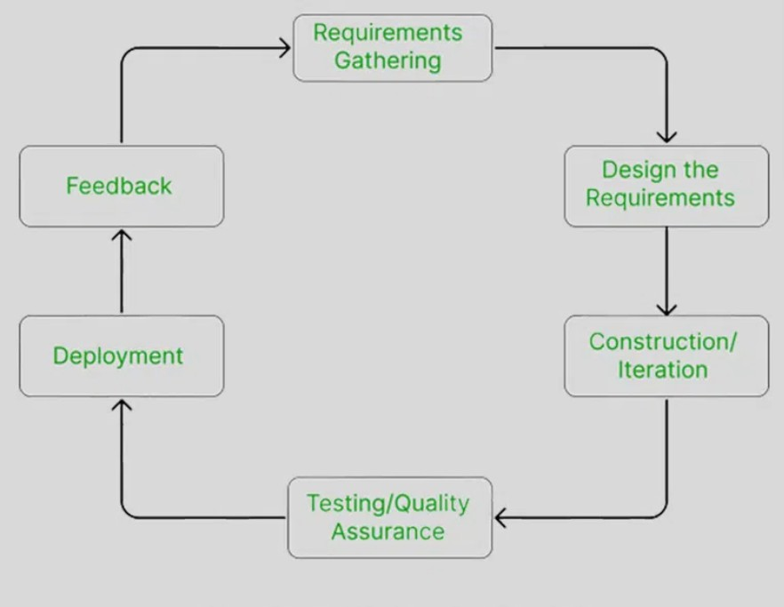

### Figure 3.1: Agile model of Anime Store Website

**Planning**: The initial planning phase involves gathering the requirements from stakeholders and outlining the features that need to be developed. However, the goal is not to fully define all requirements upfront Agile allows these to evolve over time. The key task is to gather high-level requirements, define the project’s scope, timeline, and goals.

**Design and Development**: During each iteration, a portion of the system is designed and developed. Agile emphasizes simplicity and working code, and each sprint involves building and refining a set of features. The key task is to design user interfaces, system architecture, and components for the features to be built, and implement the system features based on the design. Regularly review the design to ensure that it can accommodate changes as development progresses.

**Testing**: Testing is done continuously in Agile, often as part of each iteration. Unit testing, integration testing, and sometimes user acceptance testing (UAT) are conducted in parallel with development to ensure that the system meets the required functionality and is free of bugs. The key task is to conduct automated and manual testing of the features developed during each sprint and fix defects identified during testing.

**Review**: After each iteration, the developed features are reviewed by the stakeholders to assess if they meet the defined requirements. The team collects feedback and adjusts the project as needed for the next sprint.

**Release**: At the end of each sprint, working software is delivered. This software may not be the final product, but it should be a functional part of the overall system that can be used by end-users. The key task is to deliver the incremental functionality to stakeholders and deploy any new features to production (if applicable).

**Iteration**: The Agile process is iterative, meaning the development team revisits the cycle after each sprint to improve upon the system with new features, fixes, or enhancements. This continuous process helps improve the system over time based on real-world usage and feedback.

## Requirement Analysis

### Functional Requirements

* + **Customers**
    - Allow customers to purchase.
    - Allow customers to change their account details.
    - Allow customers to register and login.
    - Allow customers to view products details.
    - Allow customers to perform transaction via different payment method.
    - Allow Customers to generate Bills.

### Admin

* + - Allow admin to insert products and categories.
    - Allow admin to modify the products details.
    - Allow admin to manage the order and view payment.
    - Allow admin to view all the users.

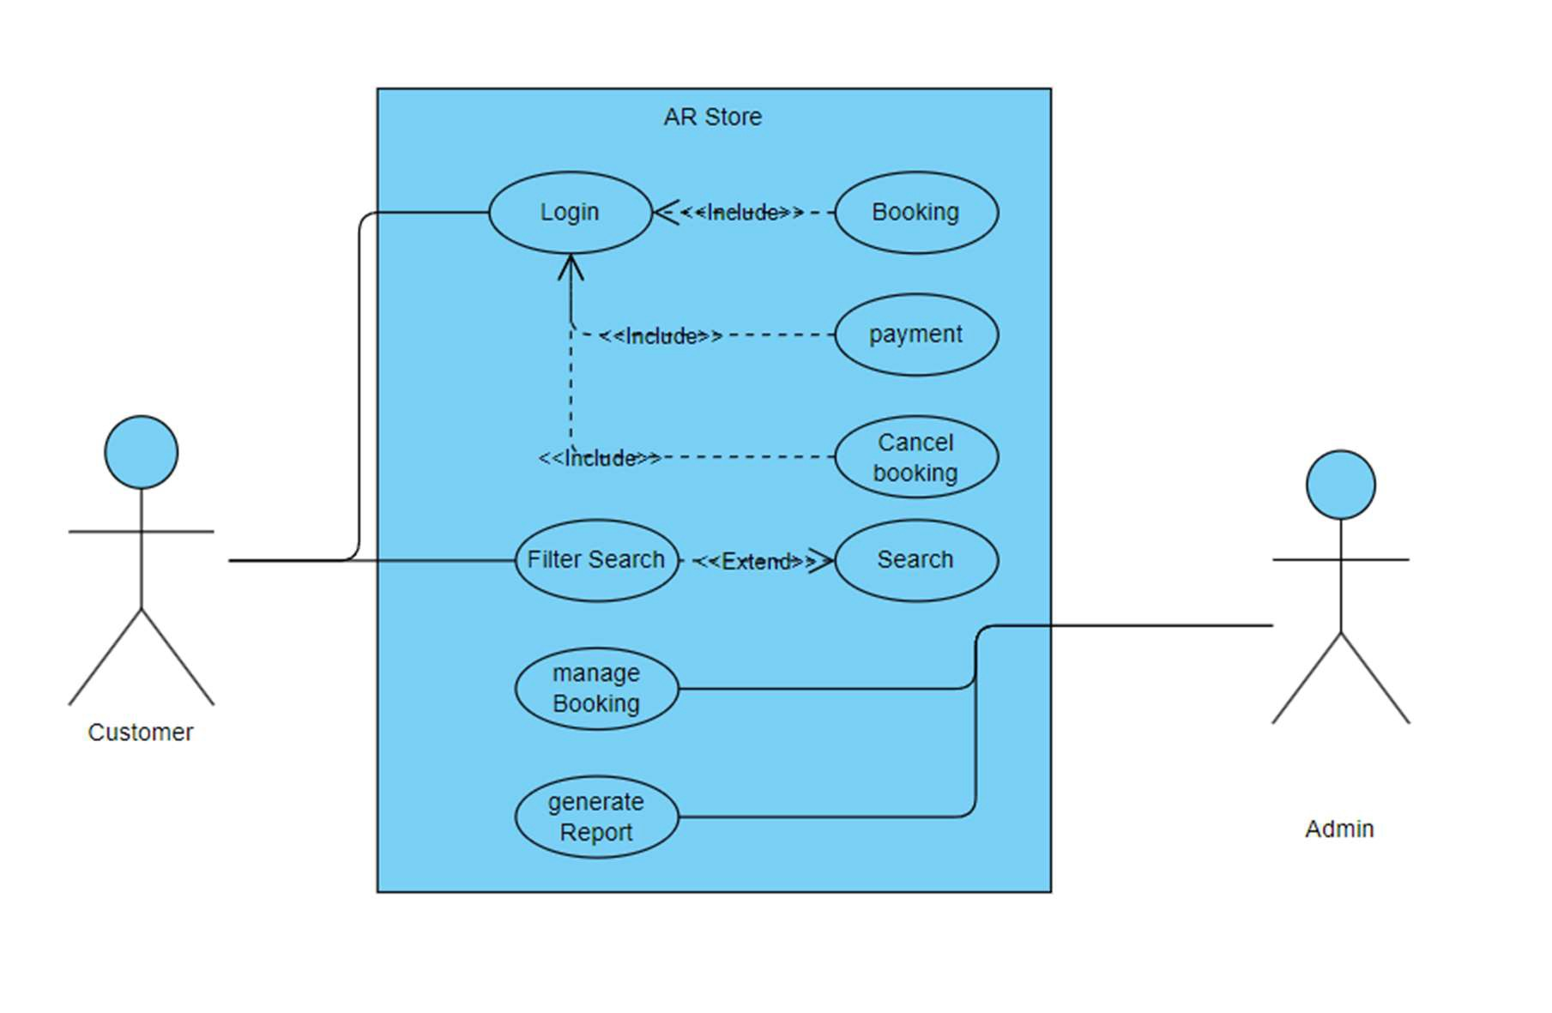

**Fig:3.2 Use-case Diagram**

* **Non-Functional Requirements**
  + **Reliability**

The Server performs desired tasks as expected. The system does its work with more accuracy like user registration to the system, user validation and authorization, and issue operation, return status, and updating the database.

### Scalability

The proposed system would be scalable to support an extended number of users.

### Security

The system provides access to only legitimate users. It will be secure on a network and only authorized persons can access it.

### Maintainability

The proposed system would be easy to maintain and extend. Minor modifications to the system would not cause harm to the running application.

## Feasibility Analysis

It is wise to think about the feasibility of any problem we undertake. Feasibility is the system of impact, which happens in the organization by the development of the system. The impact can be either positive or negative. When the positive nominates the negatives, then the system is considered feasible.

### Technical Feasibility

We can strongly say that is technically feasible since there will not be more difficulty in getting the required resources for the development and maintenance of the system.

All the resources needed for the development of the software as well as the maintenance of the same are available in the organization. We are utilizing the resources that are already available.

### Operational Feasibility

Operation feasibility is a measure of how well a proposed system solves problems and takes advantage of the opportunities identified during scope definition and how it satisfies the requirements identified in the requirements analysis phase of system development.

### Economic Feasibility

The development of this application is highly economically feasible. We did not spend much money on the development of the system. The only thing to be done is to make an environment for development with effective supervision. If we are doing so, we can attain the maximum usability of the corresponding resources. Therefore, the system is economically feasible.

### Schedule Feasibility

The schedule feasibility shows the estimated time to complete the project. This includes the schedules of each process in a project and the total project time. This can change if an unexpected challenge occurs.

### Gantt Chart

This allows us to see at a glance:

* + - * + What the various activities are
        + When each activity begins and ends
        + How long each activity is scheduled to last The Various Phases of the Project:

|  |  |  |
| --- | --- | --- |
| **S.N.** | **Phase** | **Task Duration** |
| 1. | Planning | 6 Days |
| 2. | Design and Development | 27 Days |
| 3. | Testing | 10 Days |
| 4. | Review | 7 Days |
| 5. | Release | 1 Days |

### Table 3.1: Project Schedule for Anime Store

The Gantt Chart of Anime Store has a start date and end date for each phase. It has weeks moving from left to right and phases of the Agile Methodology moving across the vertical axis.

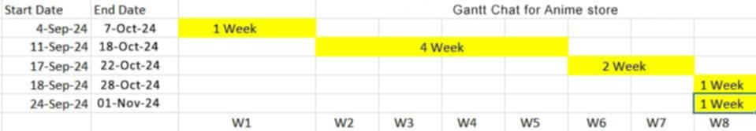

### Figure 3.3: Gantt-Chart of Anime Store

During the research for this system, various requirements were collected for this system and the requirements were analyzed for 5 days. For the next 15 days, various activities related to system design such as database design, data modeling, process modeling and many more were performed. The designs were implemented into a working system in another 2.5 weeks. The system was then tested for any bugs and errors for another week.

## Data Modeling (ER-Diagram)

In this system, there are five different entities namely: Admin, Products, Category, User, Cart

. They are related to each other. A User has various attributes including: user_username, user_id, user_email, user_password, user_mobile and many more. Cart have attributes like product_id and Quantity.

Products has attributes like Product_id, Product_name, product_description, product_price etc. And Admin have following attributes: admin_id, email, password and username. For this system, following ER Diagram was developed during the data modeling:

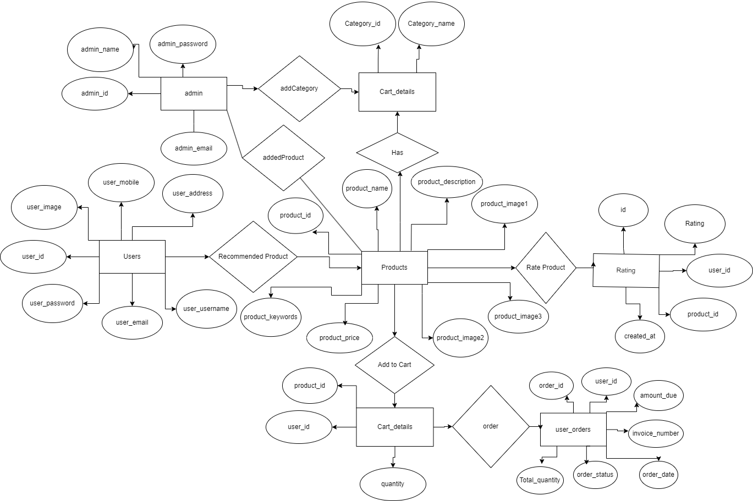

**Figure 3.4: ER Diagram of Anime Store**

## Process Modeling (DFD)

For Process Modeling of Anime Store Project, a context diagram (Level-0 DFD) and Level-1 DFD of the system was designed. The figures below shows the context diagram and level-1 DFD for Anime Store are shown:

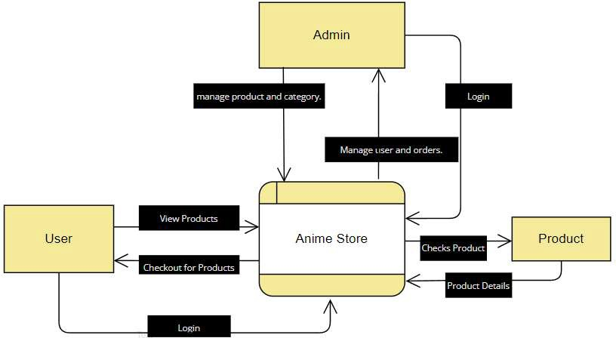

**Figure 3.5: Context – Diagram of Anime Store Website**

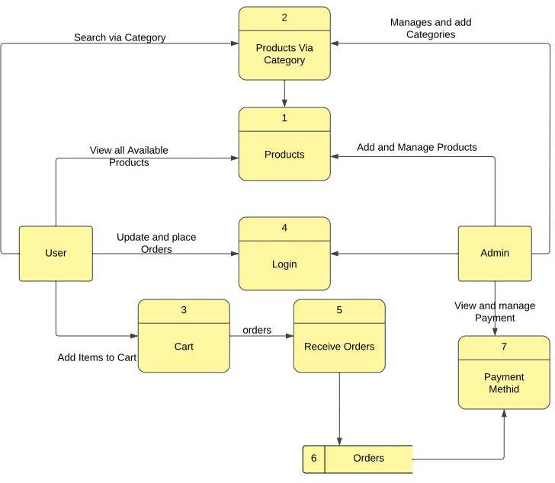

**Figure 3.6 : Level 1 DFD of Anime Store Website**

## System Design

The system is collectively developed with HTML, CSS, JavaScript as front end and PHP, MySQL as backend. Each of those phases are explained below:

### Architectural Design

This system follows data-centered architecture. All the data are stored in the database and is accessed by all the parties involved with the system. Features like User Authentication, User Registration, Viewing Information and editing profiles are included in the Front-end portion. Report Generation, Security, Strengths and Forms are included in the processing.

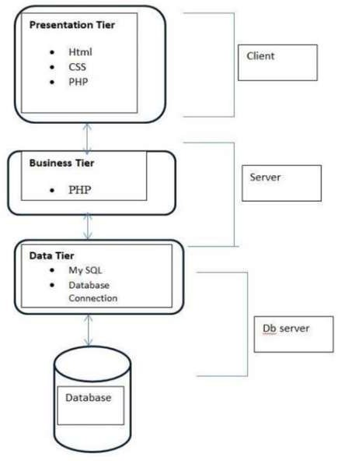

### Figure 3.7: System Architecture Design of Anime Store Website

### Database Schema Design:

Database schema design establishes the structure and relationships between data entities in the anime store. It defines tables, attributes, primary keys, and foreign keys, ensuring organized data storage and retrieval. An efficiently designed schema enables seamless management of user information, items, orders, and feedback, contributing to the system's overall performance and functionality.

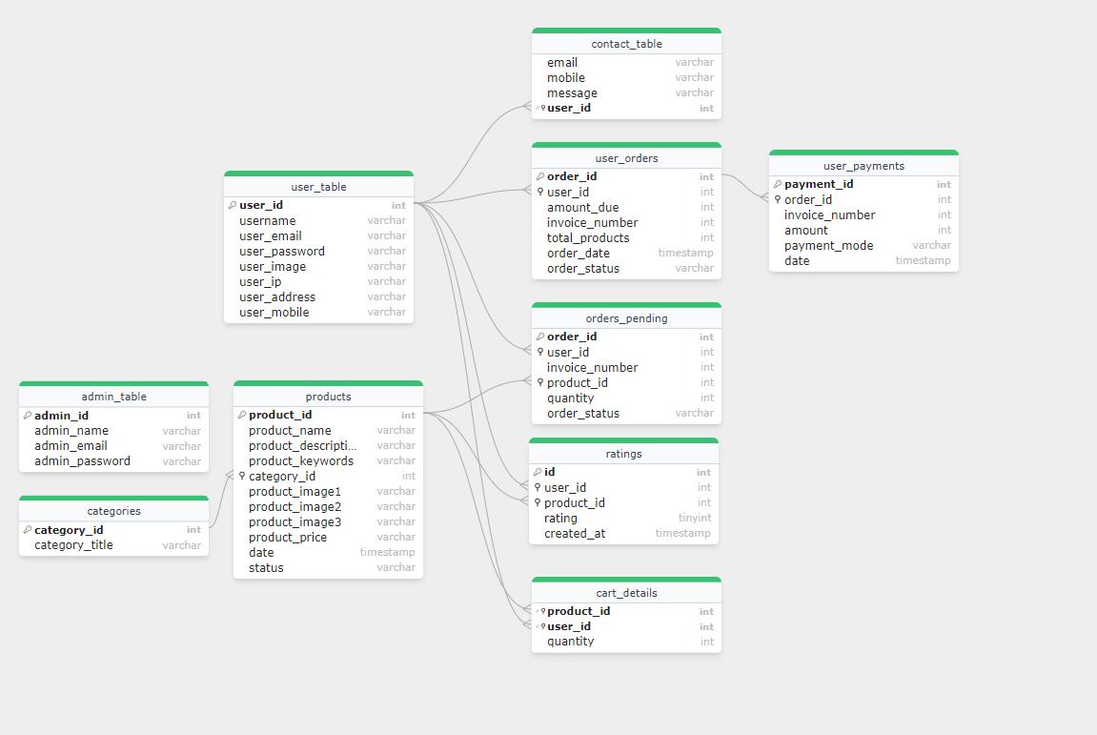

### Figure 3.8: Database Schema Design of Anime Store

### Interface Design

During Interface Design, wireframe designs were created for the system. Draw.io was used as a mockup tool during the interface design. Various mock-ups designed for the interfaces of Anime Store are shown below:

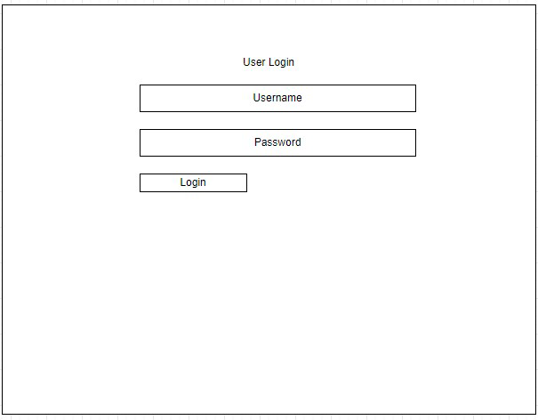

**Figure 3.9: Login Page Wireframe**

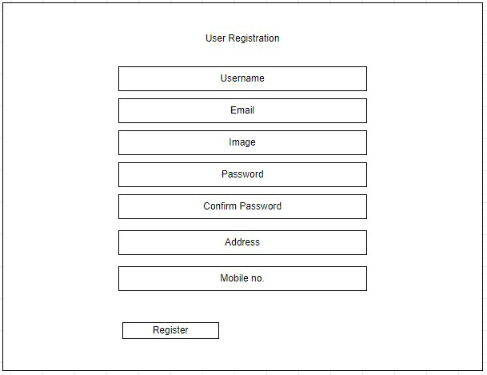

**Figure 3.10: Registration Page Wireframe**

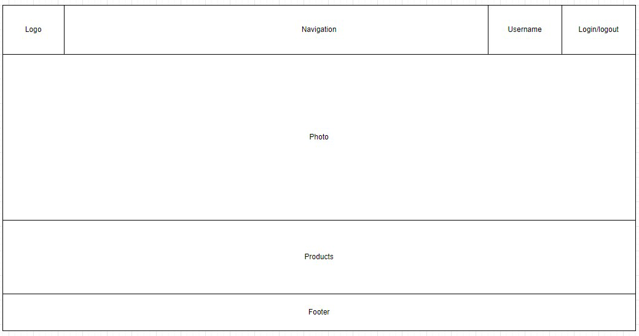

**Figure 3.11: User Homepage Wireframe**

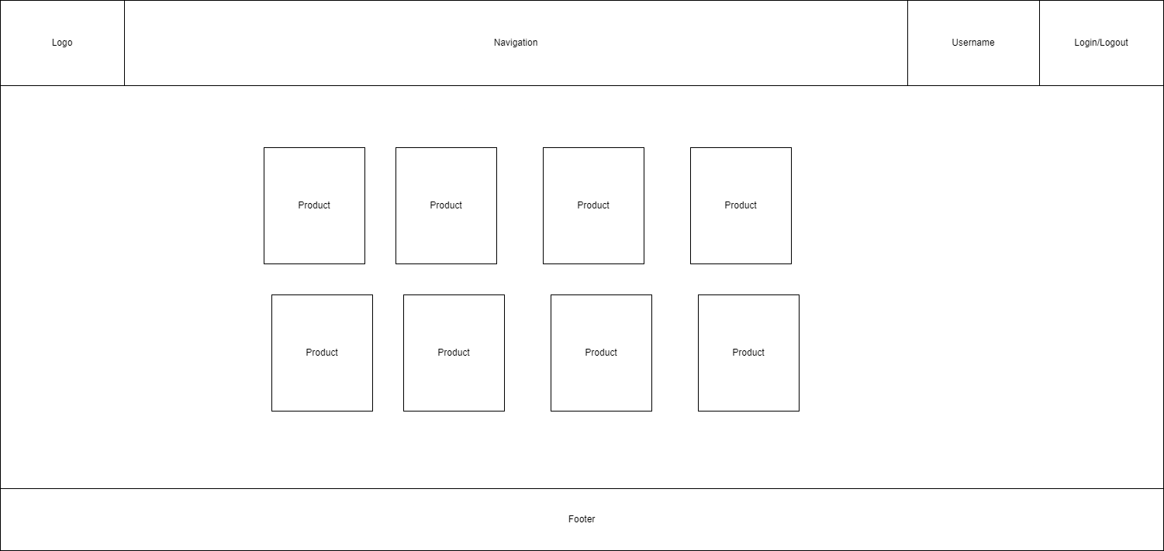

**Figure 3.12: User Product Page Wireframe**

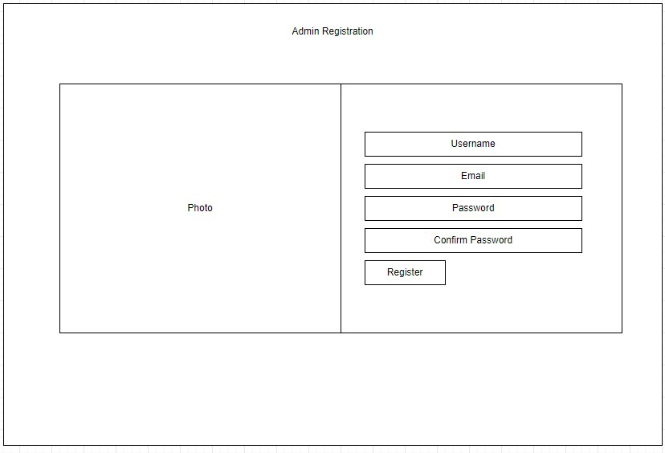

**Figure 3.13: Admin Registration Page Wireframe**

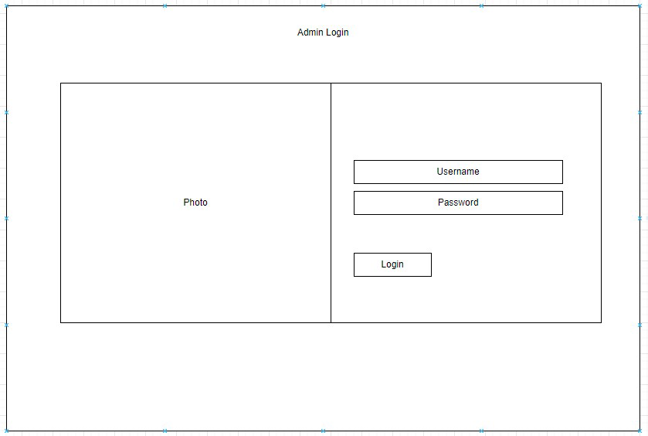

**Figure 3.14: Admin Login page Wireframe**

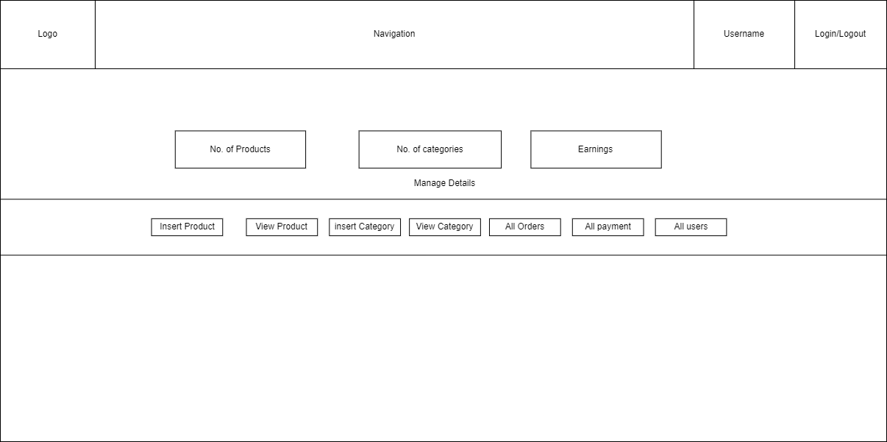

**Figure 3.15: Admin Dashboard Wireframe**

### Physical DFD

1. Zero level data flow diagram of Anime Store Website:

This is the zero level DFD of Anime Store Website. It’s a basic overview of the whole Anime Store Website, Products, admin, Customer and confirmation detail in zero level DFD of Anime Store Website. The Anime Store includes following three external entities namely Users, products and Admin. Each entities are related through the Anime Store Website as a process. The products can be found by the categories, and users can add the items to the carts which is on the website and the admin controls and manage the details about the products , categories, payments and users info. Admin can also view, update, delete the products, categories, payments and no. of users.



**Figure 3.16: Level 0 Physical DFD of Anime Store Website**



**Figure 3.17: Level 1 Physical DFD of Anime Store Website**

## Algorithm Used

The algorithm used in this project is Recommendation of Products According to Highest Product Rating. The recommendation algorithm in this project is based on a 5-star rating system that focuses on customer feedback for products. Customers rate products on a scale from 1 to 5, with a higher rating showing greater satisfaction. Products with the highest ratings are then recommended to other customers.

1 Star: Very Poor

2 Stars: Poor

3 Stars: Average

4 Stars: good

5 Stars: Excellent

To illustrate the practical application of the average calculation, let's consider an example. Imagine that 15 Customers rated the one of the products, with the following breakdown:

4 Customers gave 5 stars

5 Customers gave 4 stars

1 Customers gave 3 stars

1 Customers gave 2 stars

1 Customers gave 1 star

The total rating sum would be calculated as follows: 4×5 + 5×4 + 1×3 + 1×2+1×1 = 64

The average rating is then determined by dividing the total rating sum by the number of Customers [8]: 46/12=3.8

Then it is round of then the average ratting will be 4. This value will be used to show the stars in event pages

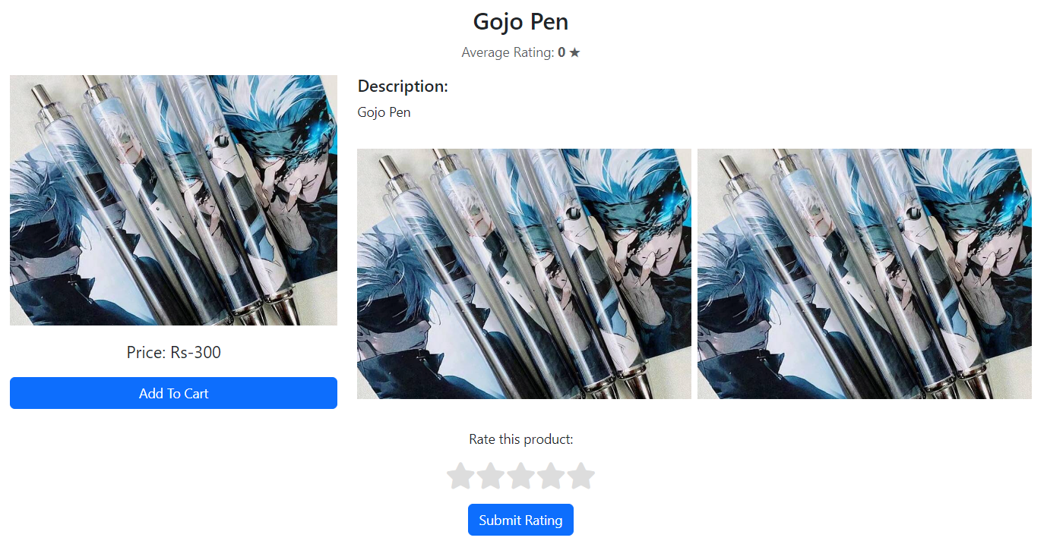

**Figure 3.18: Before Rating**

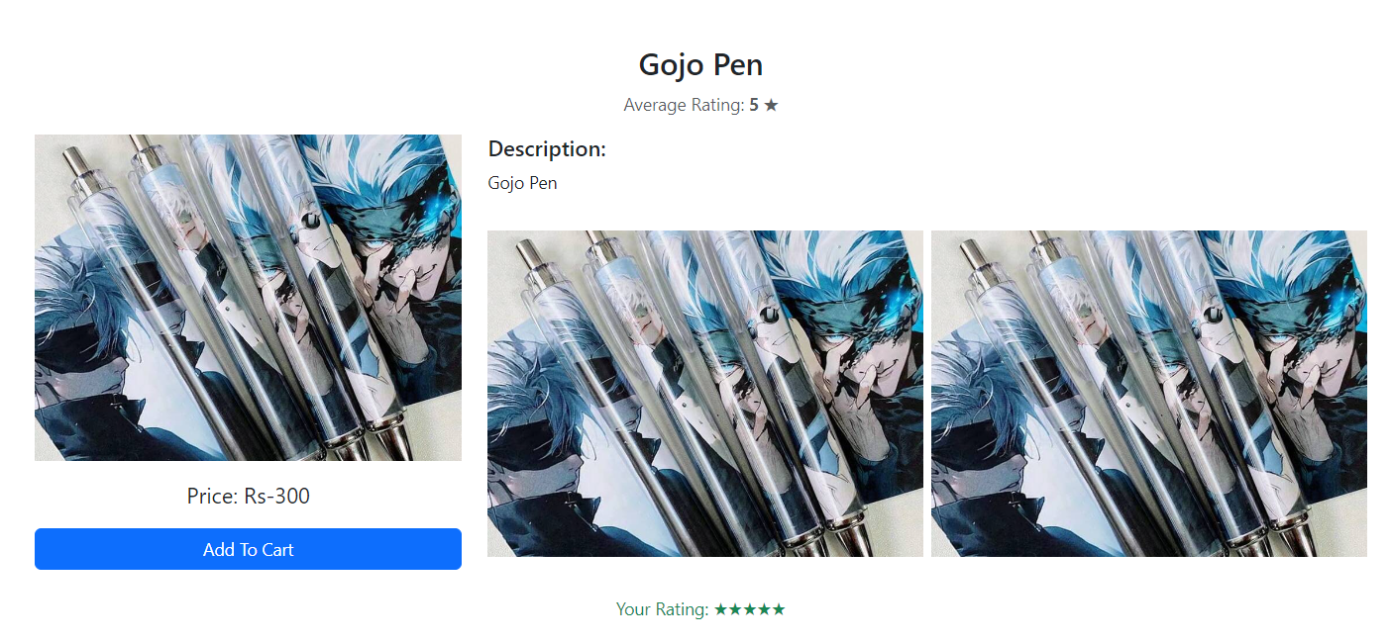

**Figure 3.19: After Rating**

Then recommendation according to high rating on the view details page below the selected product:

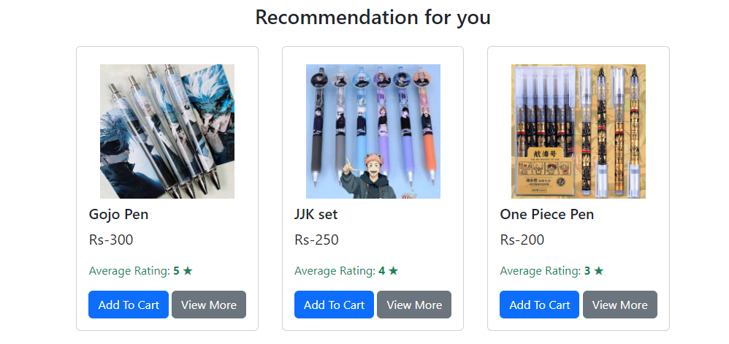

**Figure 3.20: Recommended Product**

# CHAPTER 4: IMPLEMENTATION AND TESTING

## Implementation

The system has been implemented using the following technologies: MySQL for creating database, HTML and CSS for designing and styling the interfaces, bootstrap for creating codes that link the forms to the database. Visual Studio Code has been used as the code editor for the system.

### Tools Used

* + - * **HTML:** Hypertext Markup Language, commonly abbreviated as HTML, is the standard markup language used to create web pages. Along with CSS, and JavaScript, HTML is a cornerstone technology used to create web pages, as well as to create user interfaces for mobile and web applications. Web browsers can read HTML files and render them into visible or audible web pages. HTML describes the structure of a website semantically and, before the advent of Cascading Style Sheets (CSS), included cues for the presentation or appearance of the document (web page), making it a markup language, rather than a programming language.
      * **CSS:** Cascading Style Sheets is a style sheet language used for describing the look and formatting of a document written in a markup language
      * **JavaScript:** JavaScript is a high-level, dynamic, untyped and interpreted programming language. It is the programming language of HTML and the web.
      * **PHP:** PHP is a server-side scripting language designed for web development but also used as a general-purpose programming language. Originally created by Rasmus Lerdorf in 1994, the PHP reference implementation is now produced by The PHP Group. PHP originally stood for Personal Home Page, but it now stands for the recursive backronym PHP: Hypertext Preprocessor. PHP code may be embedded into HTML code, or it can be used in combination with various web template systems, web content management systems and web frameworks.
      * **MySQL:** MySQL is a popular choice of database for use in web applications, and is a central component of the widely used LAMP open-source web application software. LAMP is an acronym for "Linux, Apache, MySQL, Perl/PHP/Python".
      * **Apache Server:** The Apache HTTP Server is the world’s most widely used web server software. Apache is developed and maintained by an open community of developers under the auspices of the Apache Software Foundation.

### Implementation Details of Modules Registration Module:

In this registration module, user has to register himself/herself to the system as a customer. His/her Credentials are checked in order to test whether the credentials are valid or not. If the credentials are valid then the user is registered to the system and he/she is redirected to the login page.

### Admin Module:

The Admin module consists of various admin level operations. He/she can register as an admin and manage the products, categories, user and many more. Admin can also delete the products, categories, users and payments.

### Customer Module:

After logging into the system successfully as a customer, they can go to their home page, where the customers are able to view the products, category pages where they can find the products they are looking for. Customers can also add items to cart and edit their accounts.

### Login Module:

Each and every user must login in order to access the services and products of the system. The login module detects each user automatically as the concept of groups has been in the system. Customer login is detected as a user automatically and admin login is detected as a admin.

### Cart and Checkout Module:

Customers can add the items to cart and continue shopping. After the product is added to cart, they can proceed to check out the product stored in cart. They must login or create an account and register in order to checkout. They can perform banking method or pay offline.

### Products and category Module:

Admin is responsible for adding product and category. A single product has a category in order to proceed. Admin can add price and description according. To add a product, admin first need to create category.

### Rating Module:

This module is used to entry new ratings in the database. Here Customer has to fill up all necessary details about the events ratings. These data gathered are first validated then stored into database using SQL query. Code where average rating algorithm is used:

<?php

$product_id = $_GET['product_id'];

$select_query = "SELECT * FROM products WHERE product_id=$product_id";

$result_query = mysqli_query($con, $select_query);

while ($row = mysqli_fetch_assoc($result_query)) {

// Product details

$product_id = $row['product_id'];

$product_name = $row['product_name'];

$product_description = $row['product_description'];

$product_image1 = $row['product_image1'];

$product_image2 = $row['product_image2']; // Assuming second image exists

$product_image3 = $row['product_image3']; // Assuming third image exists

$product_price = $row['product_price'];

// Fetch all ratings for the product

$get_ratings_query = "SELECT rating FROM ratings WHERE product_id = $product_id";

$ratings_result = mysqli_query($con, $get_ratings_query);

$total_rating = 0; // Sum of all ratings

$ratings_count = 0; // Number of ratings

while ($rating_row = mysqli_fetch_assoc($ratings_result)) {

$total_rating += $rating_row['rating'];

$ratings_count++;

}

// Calculate the average rating

$avg_rating = $ratings_count > 0 ? round($total_rating / $ratings_count, 1) : 0;

// Get the user's rating for this product

$username = $_SESSION['username']; // Assuming user is logged in

$get_user_query = "SELECT user_id FROM user_table WHERE username = '$username'";

$user_result = mysqli_query($con, $get_user_query);

$user_row = mysqli_fetch_assoc($user_result);

$user_id = $user_row['user_id'];

$get_rating_query = "SELECT rating FROM ratings WHERE user_id = $user_id AND product_id = $product_id";

$rating_result = mysqli_query($con, $get_rating_query);

$existing_rating = mysqli_fetch_assoc($rating_result);

?>

### Recommendation module:

function SimilarCategory() {

global $con;

if (isset($_GET['product_id'])) {

$product_id = $_GET['product_id'];

// 1. Fetch the category ID of the current product

$select_query = "SELECT * FROM products WHERE product_id = $product_id";

$result_query = mysqli_query($con, $select_query);

// Get category_id from current product

$category_id = 0;

if ($row = mysqli_fetch_assoc($result_query)) {

$category_id = $row['category_id'];

}

// 2. Fetch all products from the same category excluding the current product

$related_products_query = "SELECT * FROM products WHERE category_id = $category_id AND product_id != $product_id";

$related_products_result = mysqli_query($con, $related_products_query);

// 3. Initialize an array to hold products and their average ratings

$products_with_avg_rating = array();

while ($related_row = mysqli_fetch_assoc($related_products_result)) {

$related_product_id = $related_row['product_id'];

$related_product_name = $related_row['product_name'];

$related_product_price = $related_row['product_price'];

$related_product_image1 = $related_row['product_image1'];

// Fetch ratings for each product

$get_ratings_query = "SELECT rating FROM ratings WHERE product_id = $related_product_id";

$ratings_result = mysqli_query($con, $get_ratings_query);

$total_rating = 0;

$ratings_count = 0;

// Calculate the average rating

while ($rating_row = mysqli_fetch_assoc($ratings_result)) {

$total_rating += $rating_row['rating'];

$ratings_count++;

}

// Calculate average rating, default to 0 if no ratings

$avg_rating = $ratings_count > 0 ? round($total_rating / $ratings_count, 1) : 0;

// Add the product and its average rating to the array

$products_with_avg_rating[] = array(

'product_id' => $related_product_id,

'product_name' => $related_product_name,

'product_price' => $related_product_price,

'product_image1' => $related_product_image1,

'avg_rating' => $avg_rating

);

}

// 4. Sort the products by average rating in descending order

usort($products_with_avg_rating, function ($a, $b) {

return $b['avg_rating'] <=> $a['avg_rating']; // Sort descending

});

// 5. Display the top 3 products based on sorted ratings

$top_n = 3;

for ($i = 0; $i < min($top_n, count($products_with_avg_rating)); $i++) {

$product = $products_with_avg_rating[$i];

echo "

<div class='mx-3 mb-3'>

<div class='card'>

<div class='card-body'>

<img src='./admin_area/product_images/{$product['product_image1']}' class='card-img-top p-2' alt='...'>

<h5 class='card-title'>{$product['product_name']}</h5>

<p class='fs-5'>Rs-{$product['product_price']}</p>

<p class='text-success'>Average Rating: <strong>{$product['avg_rating']} ★</strong></p>

<a href='index.php?add_to_cart={$product['product_id']}' class='btn btn-primary'>Add To Cart</a>

<a href='product_details.php?product_id={$product['product_id']}' class='btn btn-secondary'>View More</a>

</div>

</div>

</div>";

}

}

}

### Search module:

This module is used to search the search word or term into the product name and keywords.

$search_query = "select * from products where product_keywords like '%$search_data_value%'";

## 4.2 Testing

The main objective of overall testing processes is to check whether developed website platforms according to the requirement. Software testing is a process that should be done during the development process.

### Test Cases for Unit Testing

|  |  |  |  |  |  |
| --- | --- | --- | --- | --- | --- |
| **S.N.** | **Unit** | **Test** | **Expected Result** | **Test Outcome** | **Evidence** |
| 1. | Customer Log In | Used Invalid log in credentials to check Login as Customer | Invalid Credential | Invalid Credential | Test 1.1,  Test 1.2 |
| 2. | Customer Log In | Used Valid Log in credentials to check Login as Customer | Login Successful | Login Successful | Test 2.1,  Test 2.2 |

|  |  |  |  |  |  |
| --- | --- | --- | --- | --- | --- |
| 3. | Admin Log In | Used Invalid log in credentials to check Login as Customer | Used Invalid log in credentials to check Login as Customer | Invalid Credential | Test 3.1,  Test 3.2 |
| 4. | Admin Log In | Used valid log in credentials to check Login as Customer | Redirect to dashboard | Redirect to dashboard | Test 4.1,  Test 4.2 |
| 5. | Registration | If username and email is same. | User and Email Already Exist | User and Email Already Exist | Test 5.1,  Test 5.2 |
| 6. | Manage Products and categories | CRUD Functionality on Products and categories | Create, Read, update and Delete Products and Categories | Create, Read,  Update and Delete Products and Categories | Test 6.1,  Test 6.2,  Test 6.3,  Test 6.4,  Test 6.5,  Test 6.6 |

**Table 4.2 Test Cases for Unit Testing**

**TEST EVIDENCE 1.1**

Unit Test: Customer Log In

Test: Check Login Credentials for invalid login credentials Expected Result: Invalid Credentials

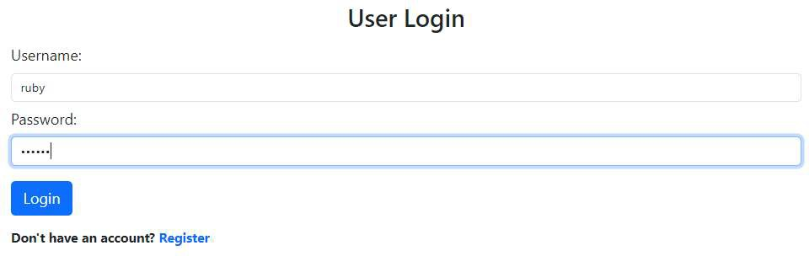

**Figure 4.1: Test Evidence 1.1**

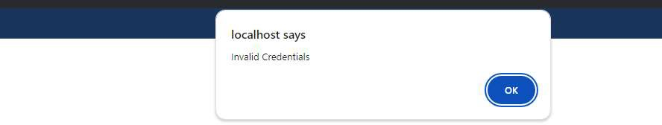

**Figure 4.2: Test Evidence 1.2**

**TEST EVIDENCE 2.1**

Unit Test: Customer Log In

Test: Check Login Credentials for valid login credentials Expected Result: Login Successful

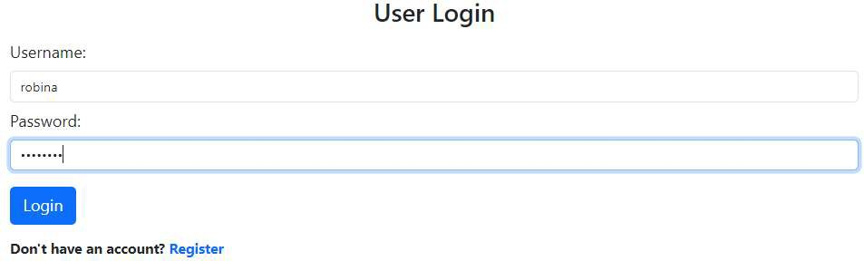

**Figure 4.3: Test Evidence 2.1**

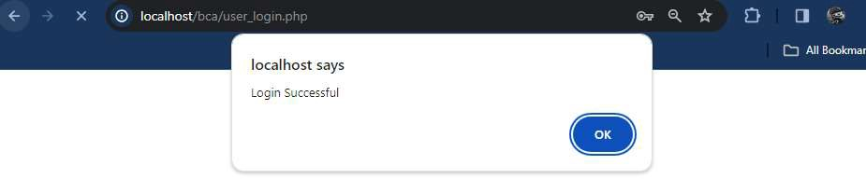

**Figure 4.4: Test Evidence 2.2**

**TEST EVIDENCE 3.1**

Unit Test: Admin Log In

Test: Check Login Credentials for invalid login credentials Expected Result: Invalid Credentials

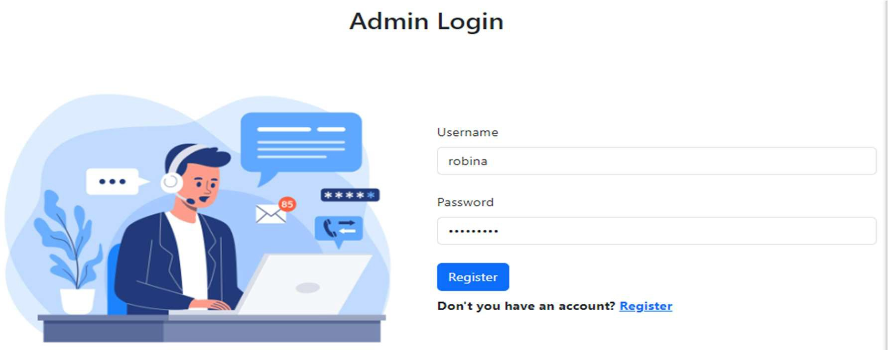

**Figure 4.5: Test Evidence 3.1**

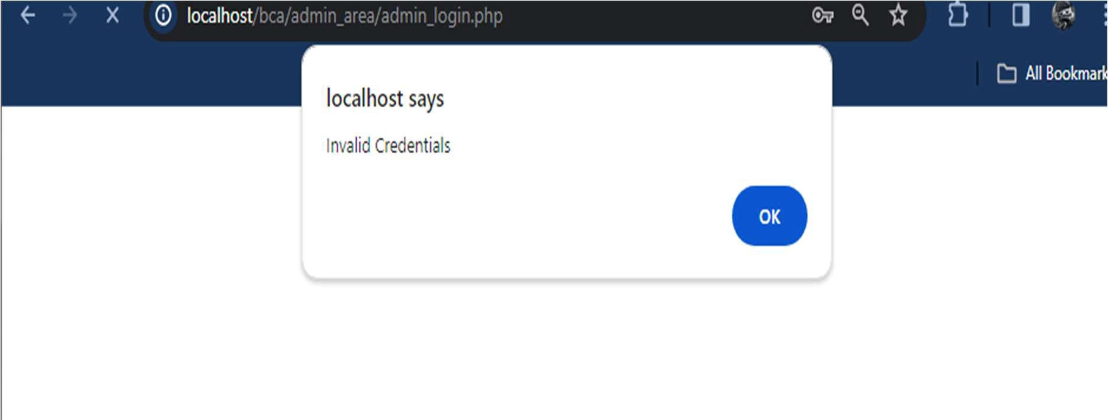

**Figure 4.6: Test Evidence 3.2**

**TEST EVIDENCE 4.1**

Unit Test: Admin Log In

Test: Check Login Credentials for valid login credentials Expected Result: Redirected to admin dashboard

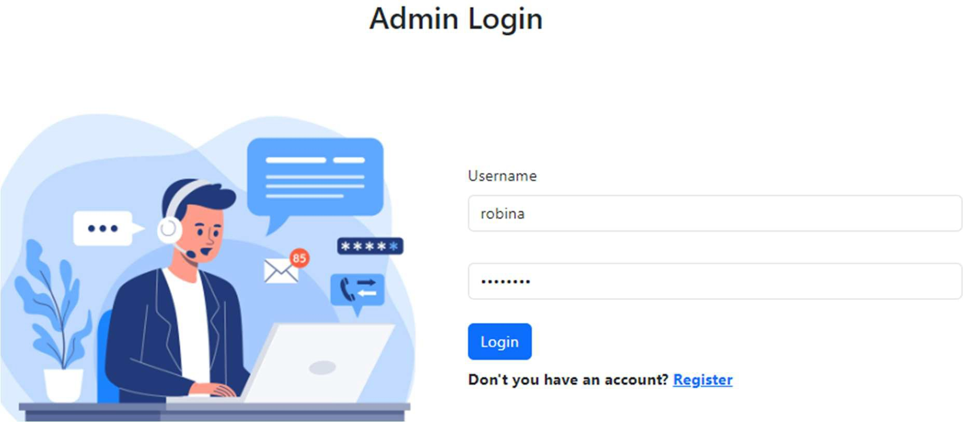

**Figure 4.7: Test Evidence 4.1**

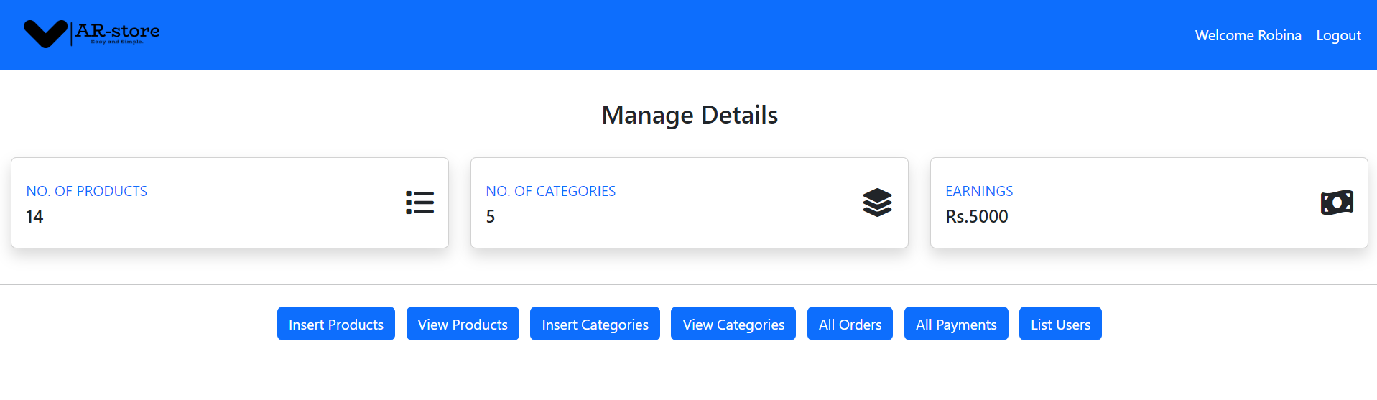

**Figure 4.8: Test Evidence 4.2**

**TEST EVIDENCE 5.1**

Unit Test: Registration

Test: If Username and email already Exist in Database Expected Result: Username and email Already Exist

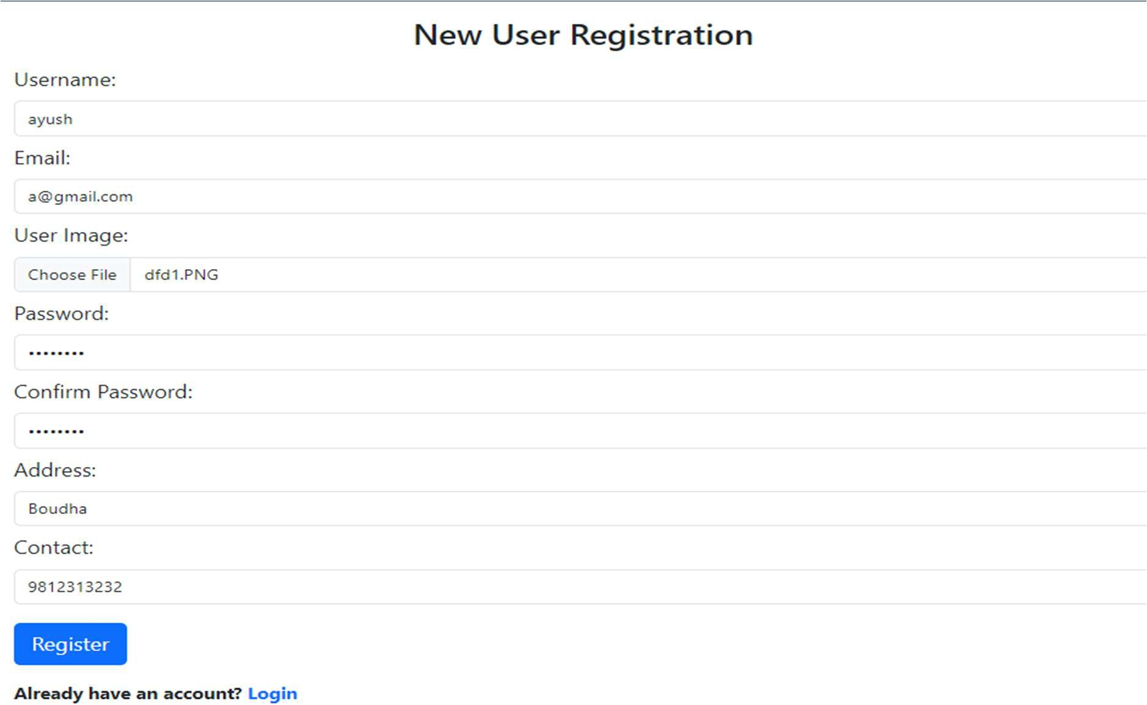

**Figure 4.9: Test Evidence 5.1**

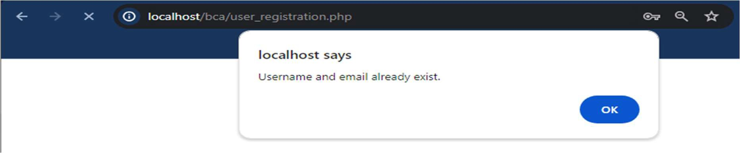

**Figure 4.10: Test Evidence 5.2**

**TEST EVIDENCE 6.1**

Unit Test: Manage Products and categories

Test: CRUD Functionalities on products and Categories.

Expected Result: Posted Products are displayed on View Products and Customer UI.

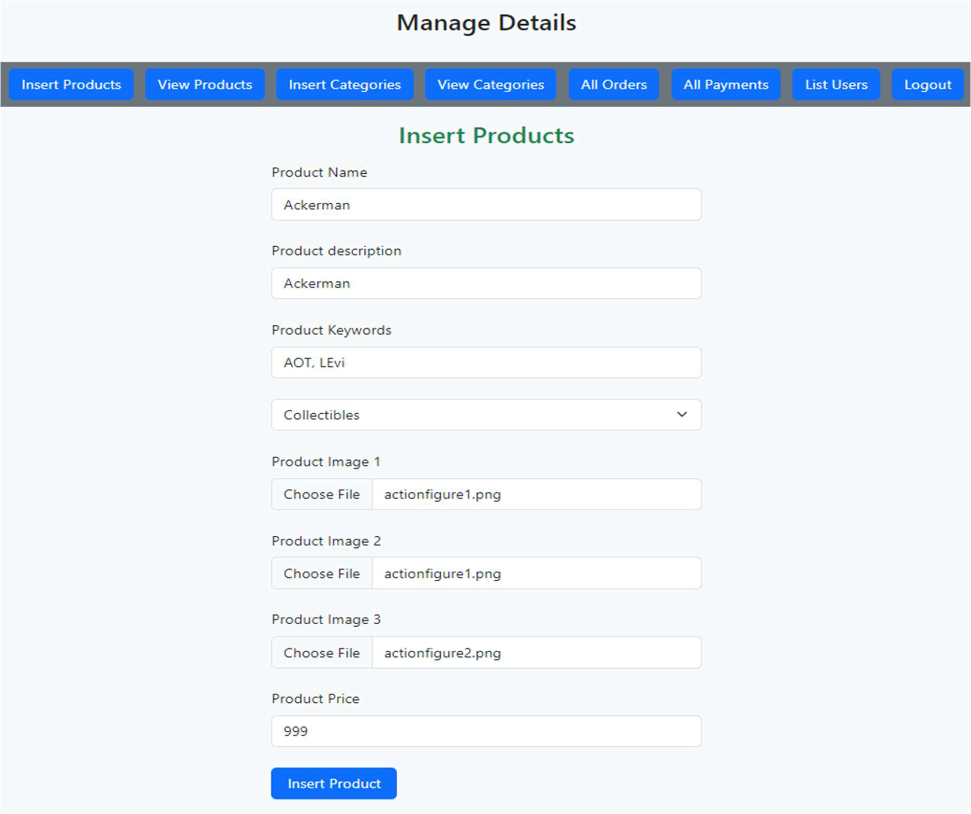

**Figure 4.11: Test Evidence 6.1**

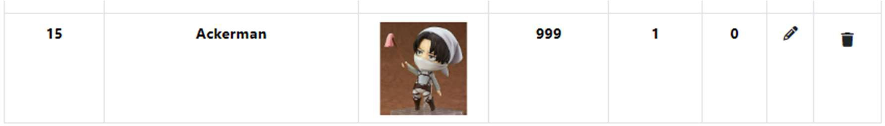

**Figure 4.12: Test Evidence 6.2**

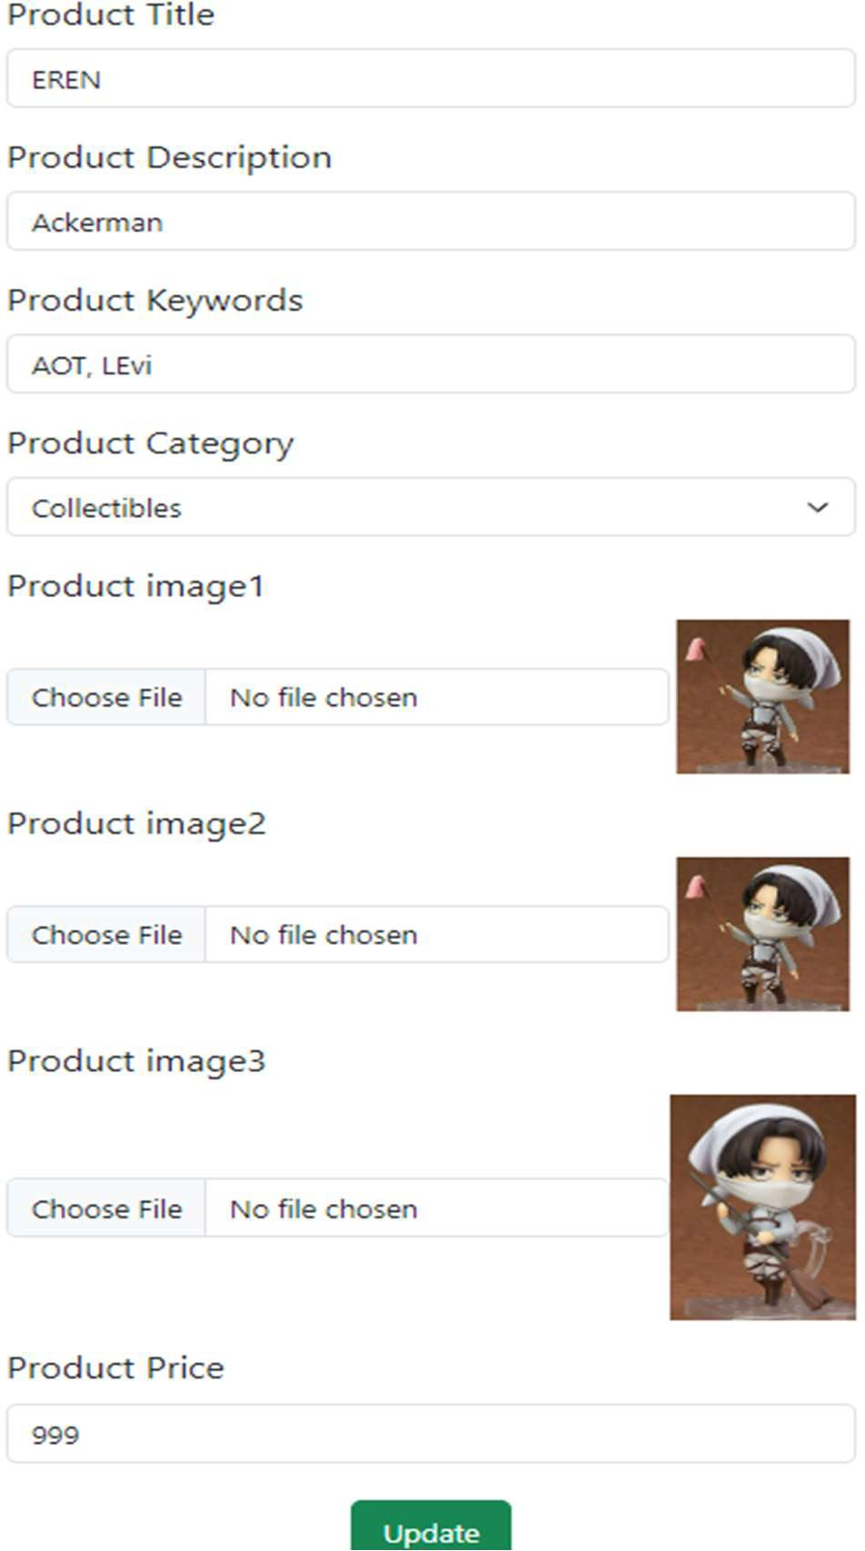

**Figure 4.13: Test Evidence 6.3**

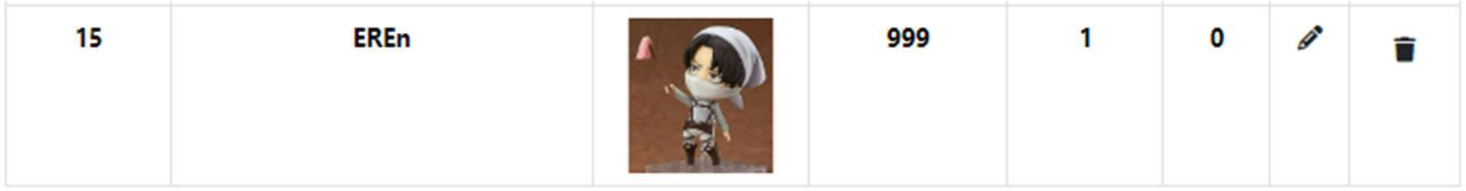

**Figure 4.14: Test Evidence 6.4**

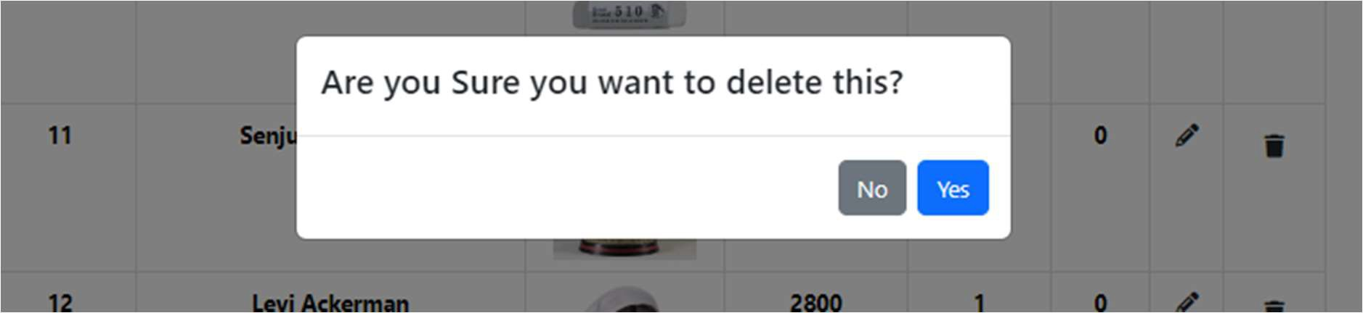

**Figure 4.15: Test Evidence 6.5**

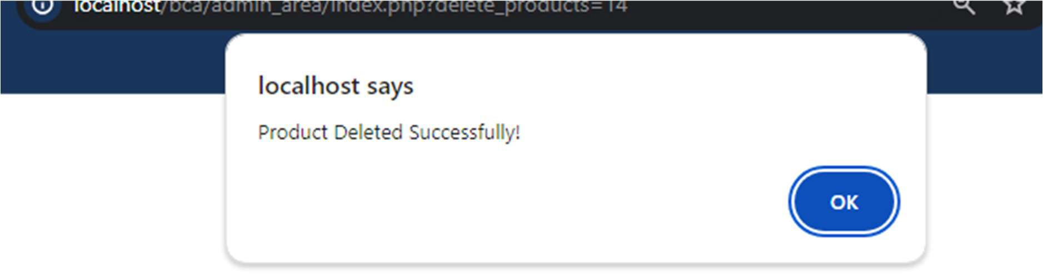

**Figure 4.16: Test Evidence 6.6**

### Test Cases for System Testing

After integrating all the modules into a workable system, the whole system was tested. Following tests were performed in the System Testing phase:

* Navigation between pages was tested.
* Registration for Customer and Admin was tested.
* CRUD functionalities was tested.

### System Evaluation

The system was used for a few days which was followed by evaluation. Our classmates were asked to use the Anime Store Website and to fill in the questionnaire in order to obtain feedback and to assess the whole system.

The survey was carried out among 10 students of our class. 30% were female students where as the rest were male. The second and third questions in the questionnaire were about features which have been built into the system. All of the participants said that they could find the Products through search bar and categories. 80% of them strongly agreed while the others disagreed.

# CHAPTER 5: CONCLUSION AND FUTURE RECOMMENDATION

## 5.1 Lesson Learnt

With the growth and development of the project, we also grew our knowledge little by little. We have learned lots of problem-solving skills and learnt things like teamwork, finding the solution on our own, proper use of guidelines, communication and writing skills and management of the team. This project didn’t only help in our academic development but also widened our horizon of curiosity. We have found ourselves more eager to learn about new languages and designing techniques while developing this project.

## 5.2 Conclusion

During the development of this website, different tasks and implementation of different frameworks were done. The development and implementation of our anime store website have been a significant undertaking, marked by a collaborative effort to create a platform that addresses the increasing anime fandom and enthusiasts. The System’s initial requirements were well known, the features were clear and simple. The Website mainly focused in purchasing of anime goods and products. The growing fandom of e-commerce and anime fandom had motivate us to create a website that offers them tons of products and goods with just a click. Furthermore, The project timeline was fixed. As the project is constrained by cost and time, and the requirements and scope were well understood, it was feasible to use Waterfall model of software development. Under the Implementation and Coding phase of the Waterfall Model of this system, each module of the system was created as a single unit and those units were finally integrated in order to obtain the final resulting system.

In conclusion, the development and maintenance of an anime e-commerce website present an exciting opportunity to engage and connect with a vibrant and passionate community of anime enthusiasts. The project creates a website offering them not only a place to shop but also a community to connect with and celebrate their shared love for anime.

## 5.3 Future Recommendations

The success of this system depends on the number of the audiences who are willing to use this system. Future modifications and developments will be done according to the feedback and reviews obtained from the users of the system. Databases will be upgraded and refined 30 frequently. User interfaces will be updated and upgraded according to the needs of the users and changes in technology. Following are the potential future enhancements:

* + - Adding coupon system
    - Recommendation of products using AI.
    - Better and Responsive User interface.
    - Improvement in performance.
    - Ensure the website is constantly updated with the latest anime releases, news, and trends.

# APPENDICES

**Home Page:**

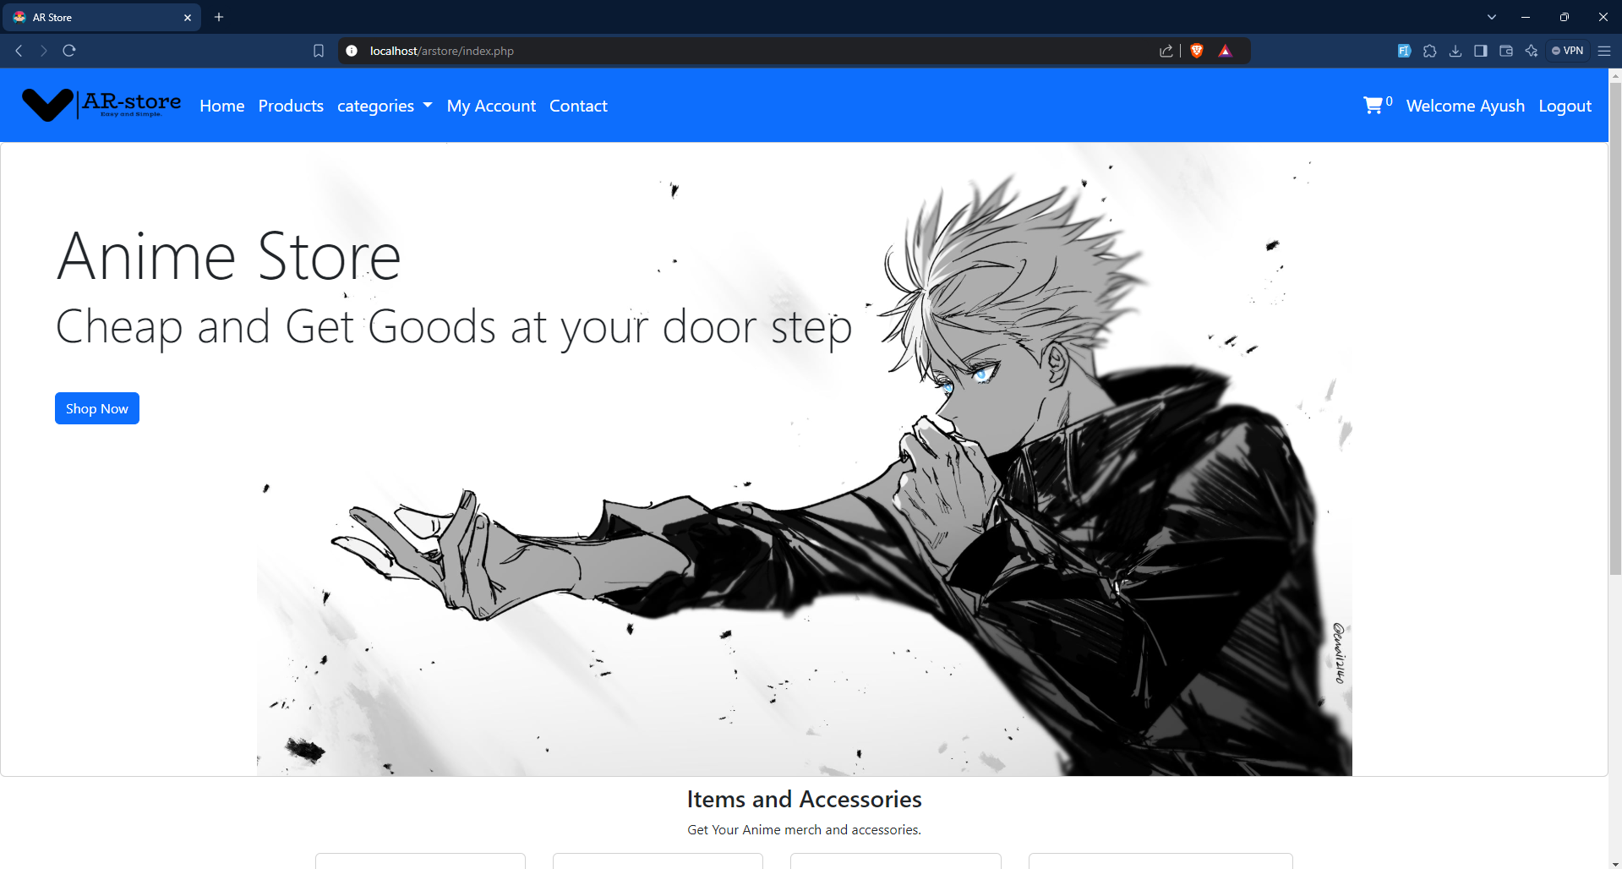

**Admin Page:**

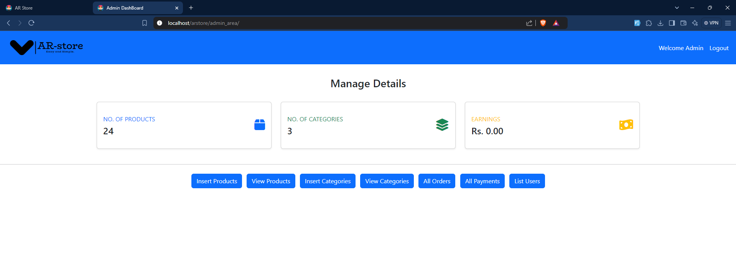

**Admin Registration:**

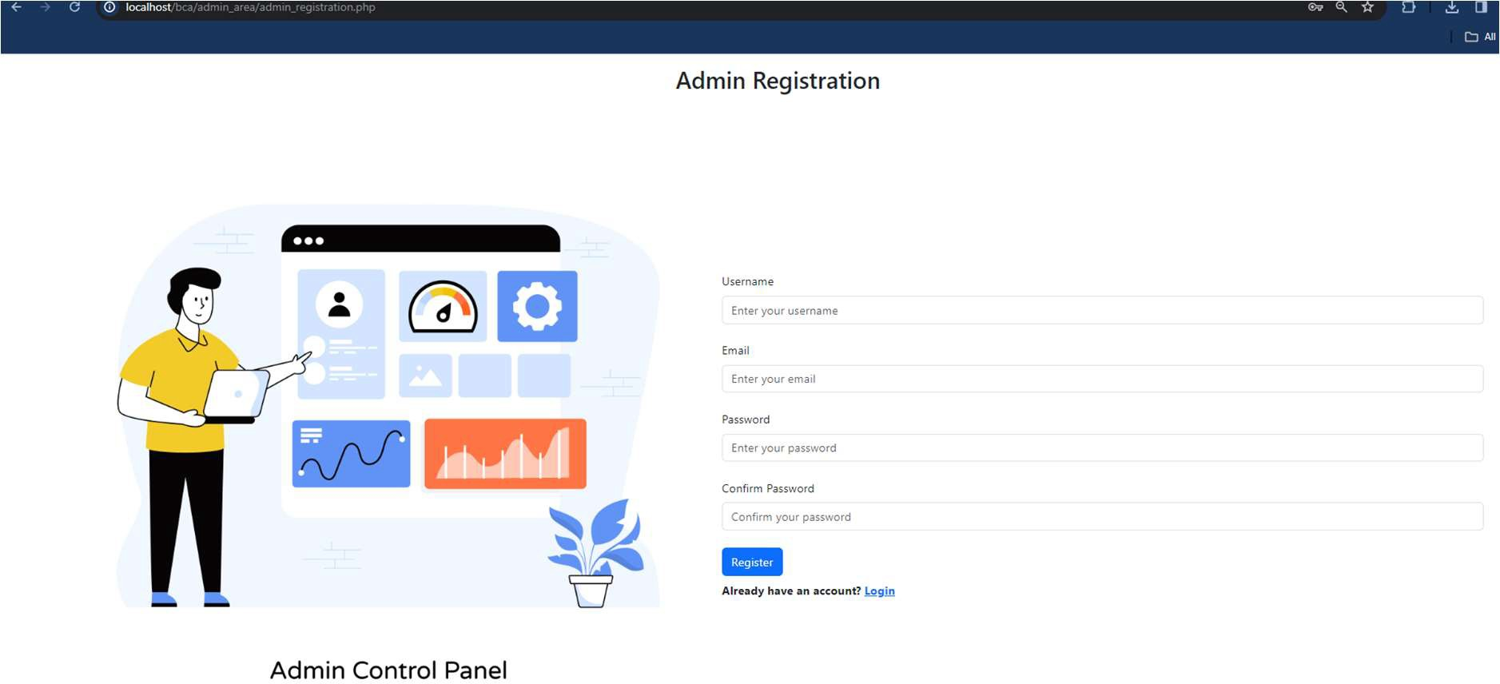

**Admin Login:**

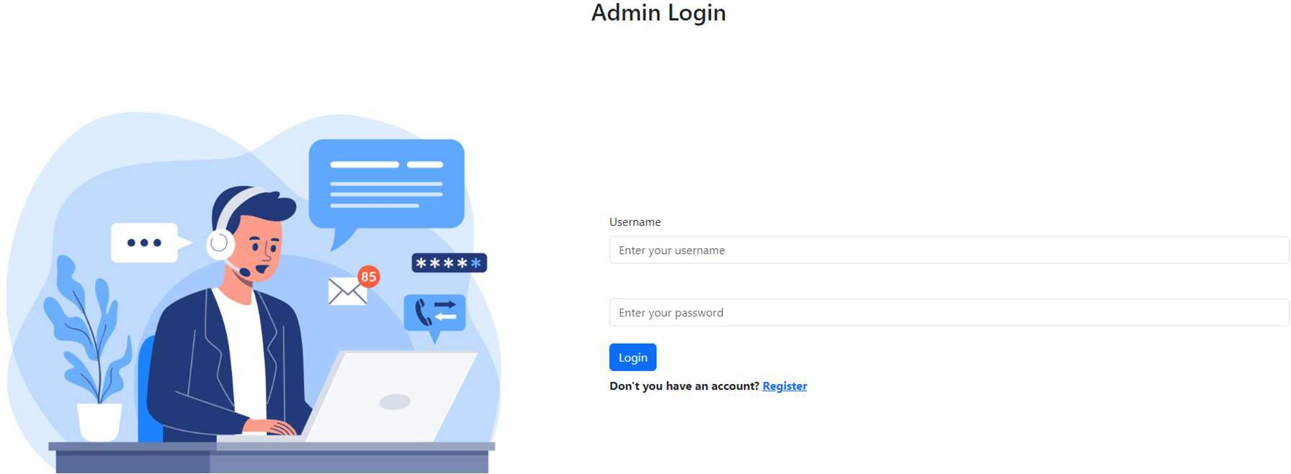

**User Registration:**

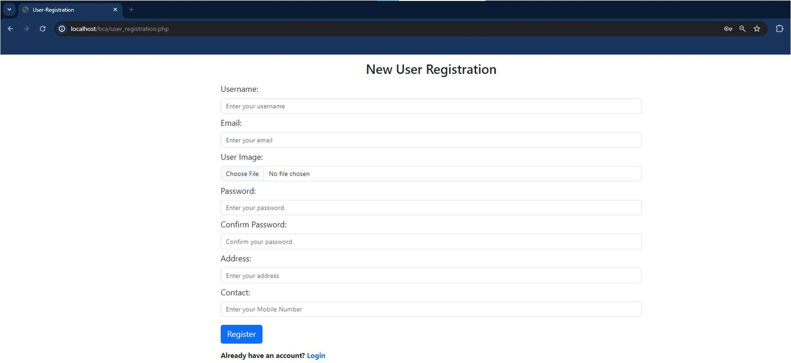

**User Login:**

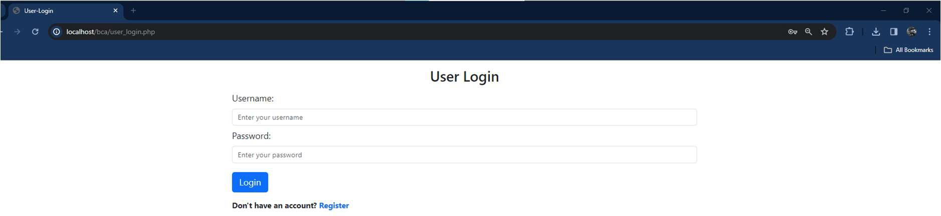

**Products Page:**

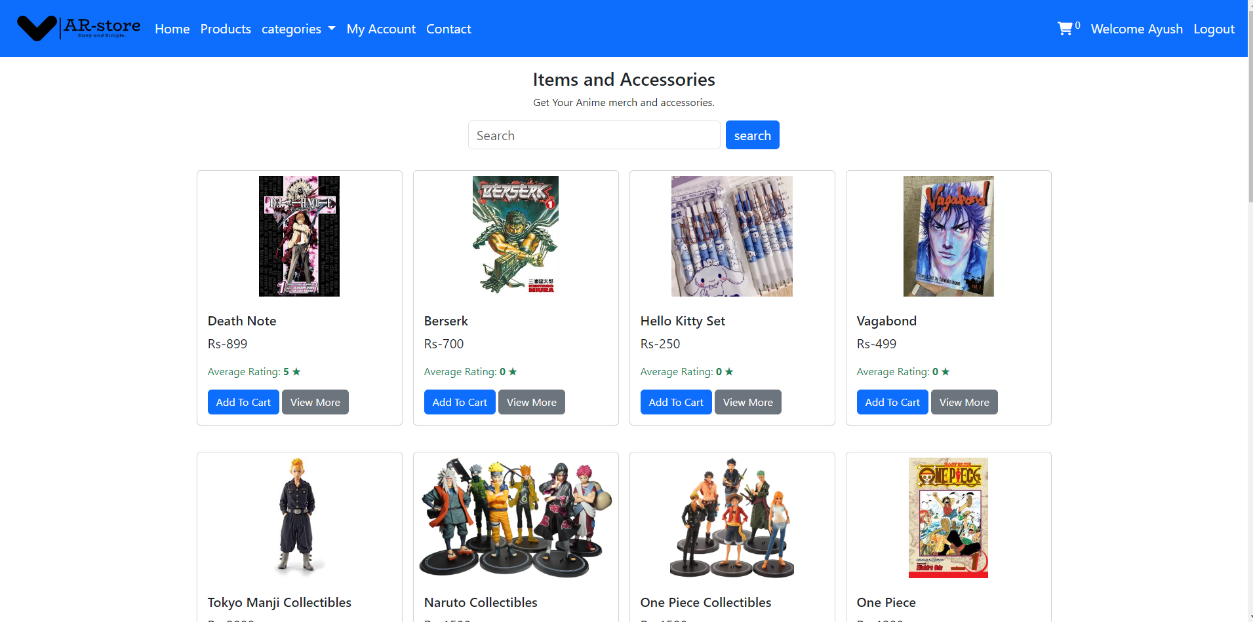

**View More Page:**

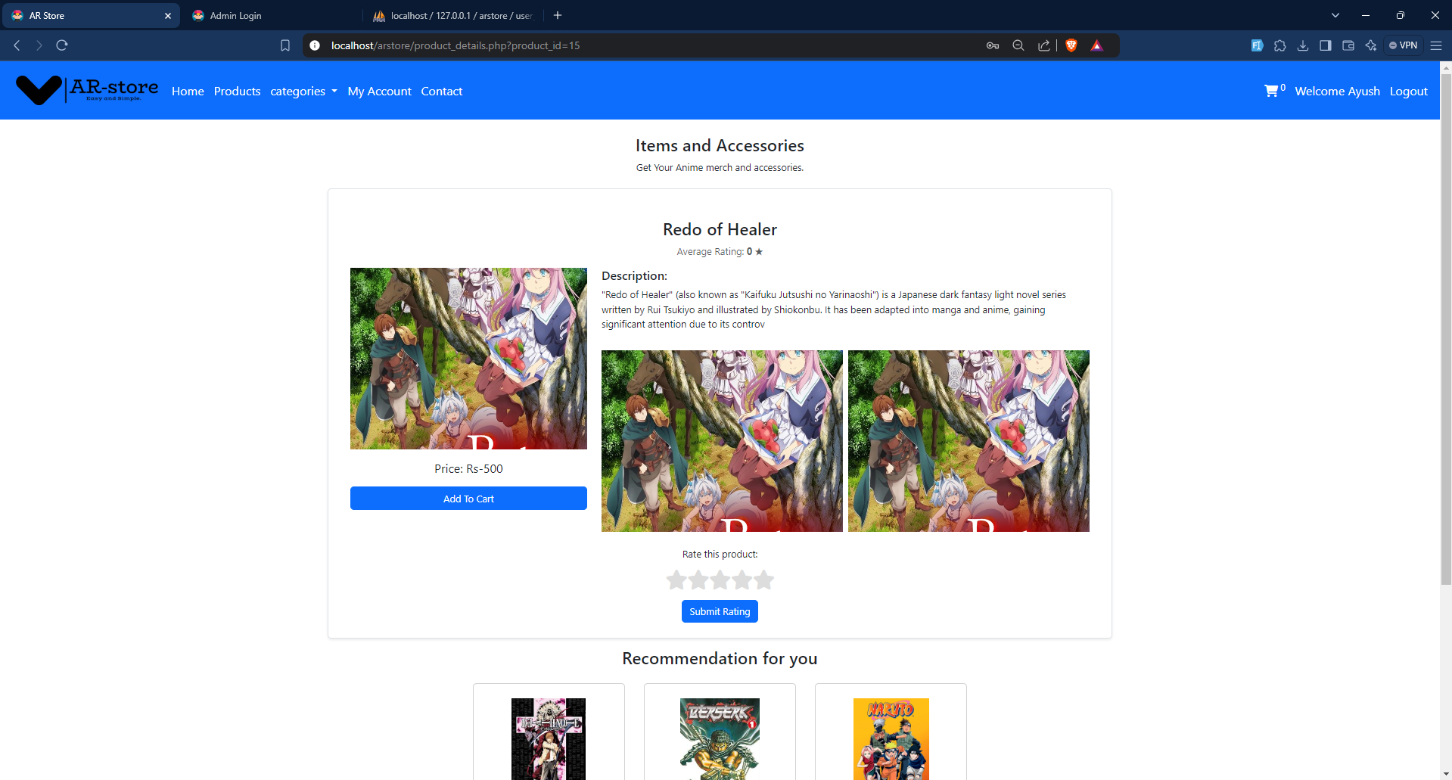

**Contact Page:**

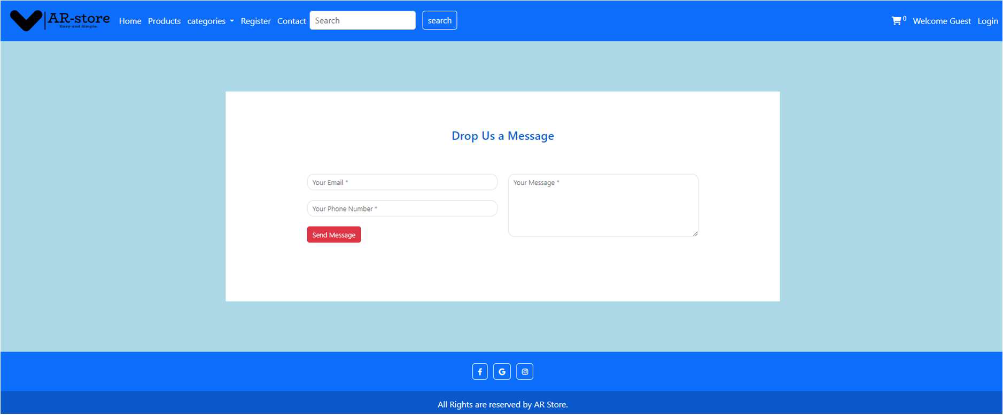

**Recommended Products:**

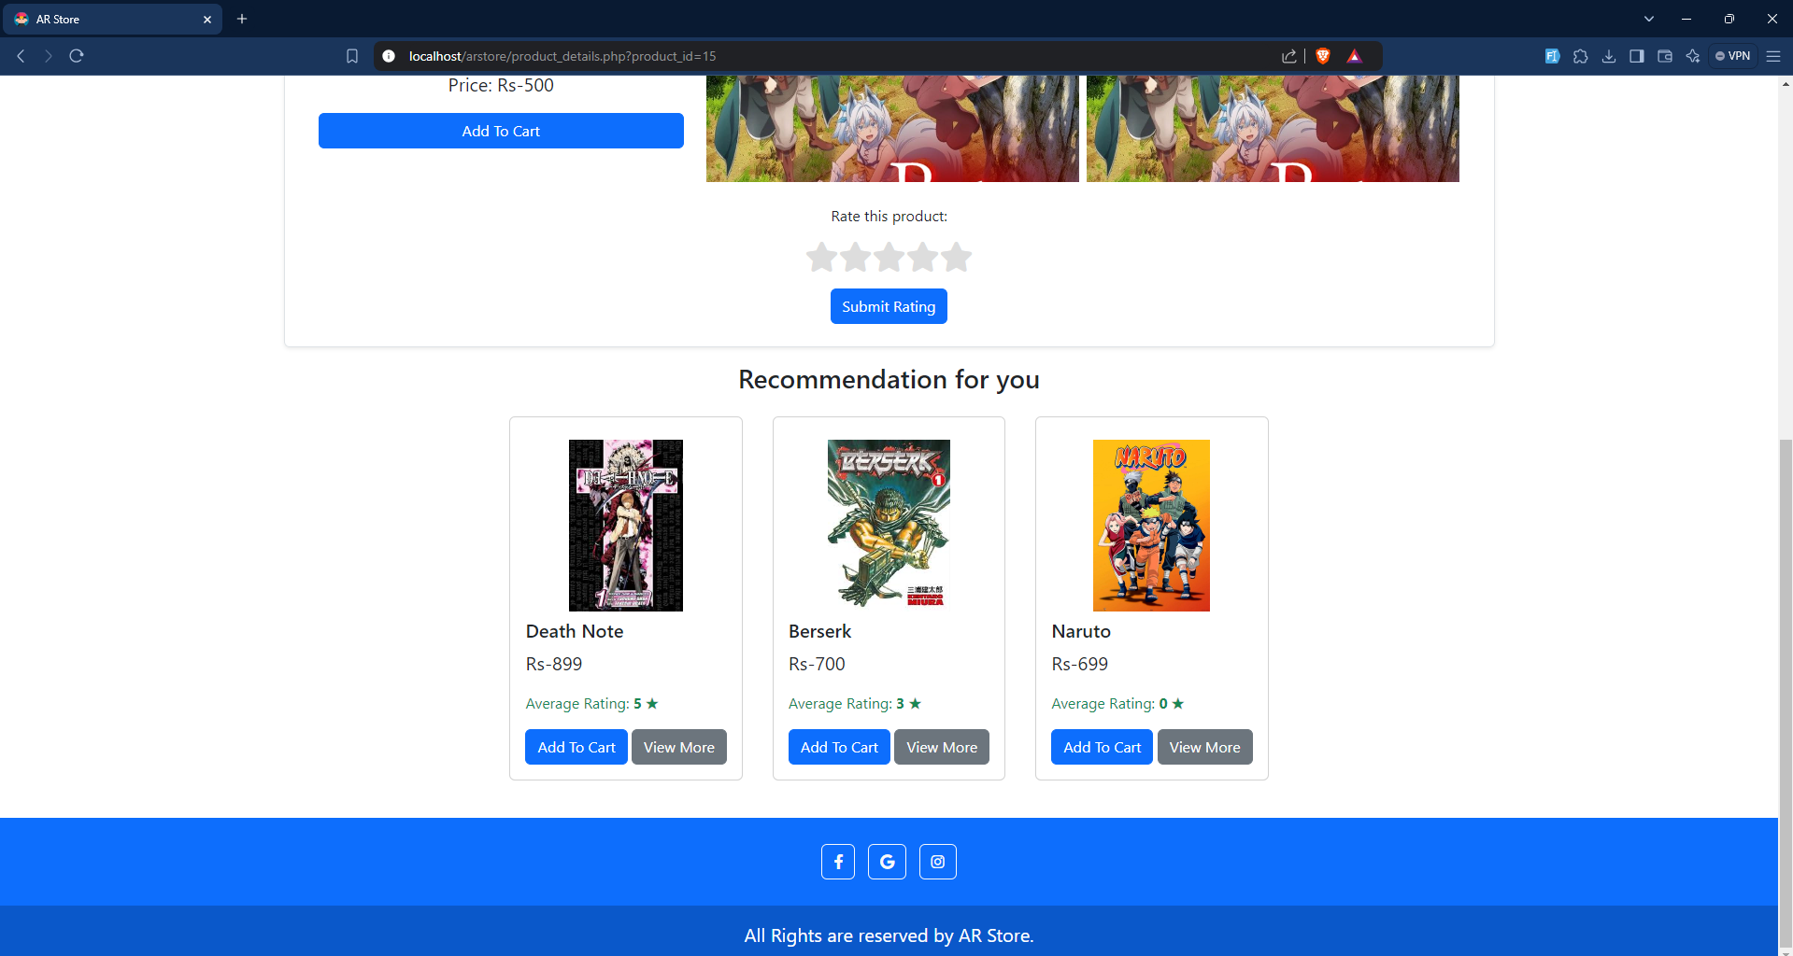

# REFERENCES

1. “Otakukulture – Anime merchandise India,” Otakukulture.in. [Online]. Available: https://otakukulture.in/. [Accessed: 01-Oct-2023].
2. “Otaku store - online shopping for Anime and Otaku merchandise with free shipping!,” Otaku Store, [Online]. Available: https://otakustore.net/. [Accessed: 09-Oct-2023].
3. Accelo, “How to Choose a Project Management Methodology”, 2021. [Online]. Available:https://[www.accelo.com/resources/blog/how-to-choose-a-project-](http://www.accelo.com/resources/blog/how-to-choose-a-project-) management- methodology/. [Accessed: 11-Nov-2023].
4. GeeksforGeeks, “Activities involved in Software Requirement Analysis”, 2021. [Online]. Available: https://[www.geeksforgeeks.org/activities-involved-in-software-](http://www.geeksforgeeks.org/activities-involved-in-software-) requirement- analysis/. [Accessed: 15-Nov-2023].
5. GeeksforGeeks, “Build an E-Commerce Web Application using HTML CSS PHP and hosted using XAMPP,” [Online]. Available: https://[www.geeksforgeeks.org/build-an-](http://www.geeksforgeeks.org/build-an-) e-commerce-web-application-using-html-css-php-and-hosted-using-xampp/. [Accessed:26-Nov-2023].